Brainstorm

& idea prioritization

Use this template in your own brainstorming sessions so your team can unleash their imagination and start shaping concepts even if you're not sitting in the same room.

## Before you collaborate

#### A little bit of preparation goes a long way with this session. Here’s what you need to do to get going.

##### 10 minutes

###### Team gathering

Define who should participate in the session and send an invite. Share relevant information or pre-work ahead.

###### Set the goal

Think about the problem you'll be focusing on solving in the brainstorming session.

###### Learn how to use the facilitation tools

Use the Facilitation Superpowers to run a happy and productive session.

**1**

## Define your problem statement

#### What problem are you trying to solve? Frame your problem as a How Might We statement. This will be the focus of your brainstorm.

##### 5 minutes

**PROBLEM**

Being understocked is also one of the inventory management problems.One of the most common challenges in inventory management is preventing the overselling of products and running out of inventory. To overcome this problem we can find valuable solutions.

**2**

## Brainstorm

#### Write down any ideas that come to mind that address your problem statement.

##### 10 minutes

###### BALAJI B

To show the accurate details of the particular stock

To check the expirying date of the product and verifying it.

To follow the fixed selling price rules of each products.

To arrange in order of the product based on their selling percentage

To generate invoice of the product by suppliers

To generate report of sales and expenditure

**AABAVANAN R**

**TIP**

Add customizable tags to sticky notes to make it easier to find, browse, organize, and categorize important ideas as themes within your mural.

**TIP**

You can select a sticky note and hit the pencil [switch to sketch] icon to start drawing!

# 

To track and alert stock quantity details to retailers

To compare price details of products from the past and displaying the differnces.

Retailers can clarify about the available products using chatbot

Payments between suppiler and retailer made easily using UPI account transactions

After every transaction feedback system is made between retailer and supplier

To provide account for every retailer and can access by logging into thier account.

**3**

## Group ideas

#### Take turns sharing your ideas while clustering similar or related notes as you go. Once all sticky notes have been grouped, give each cluster a sentence-like label. If a cluster is bigger than six sticky notes, try and see if you and break it up into smaller sub-groups.

##### 20 minutes

**Report**

**To generate invoice of the products of suppliers**

**To generate report of sales and expenditure**

**To generate report of sales and expenditure**

**Features**

**Prioritize that means top selling product goes on top it's like ABC analysis**

**Retailers can clarify about the available products using chatbot**

To update the addtional products and also can do CRUD operations.

**edit**

**4**

## Prioritize

#### Your team should all be on the same page about what's important moving forward. Place your ideas on this grid to determine which ideas are important and which are feasible.

**20 minutes**

To track and alert stock quantity details to retailers

**notification**

## After you collaborate

You can export the mural as an image or pdf to share with members of your company who might find it helpful.

**Quick add-ons**

###### Share the mural

**Share a view link** to the mural with stakeholders to keep them in the loop about the outcomes of the session.

###### Export the mural

Export a copy of the mural as a PNG or PDF to attach to emails, include in slides, or save in your drive.

**10 minutes** to prepare

**1 hour** to collaborate

**2-8 people** recommended

[**Open article**](https://support.mural.co/en/articles/2113740-facilitation-superpowers)

**To track and alert stock quantity details to retailers**

To generate report of sales and expenditure

**Report**

To provide account to every retailer and can access by logging into thier account.

**User Login**

### Key rules of brainstorming

To run an smooth and productive session

###### ARAVINTH A

Verify accuracy with regular counts

**To show the accurate details of the particular stock**

**To identify product If a product has different colors and sizes, each variation has a unique SKU number**

To view the current inventory details.

To update the addtional products and can do CRUD operations.

**Filters**

**using by retailer can easily view what they really want**

**SAKTHIVELAN S**

**Stocks**

### Keep moving forward

###### Strategy blueprint

Define the components of a new idea or strategy.

###### [Open the template](https://app.mural.co/template/e95f612a-f72a-4772-bc48-545aaa04e0c9/984865a6-0a96-4472-a48d-47639307b3ca)

**Customer experience journey map**

To implement user interface, easy to use that doesn’t require advanced training, support or documentation.

Stay in topic. Defer judgment.

Using Favourite tab retailer can add their liked product and they can view that anytime easily

Prioritize that means top selling product goes on top it's like ABC analysis

Verify accuracy with regular counts

To send e- invoice to customers through message or mail.

Encourage wild ideas. Listen to others.

**User**

To provide account for every retailer and can access by logging into thier account.

Security and Backup

Filters.

Using this retailer can view what they really want

Customer can satisfy with the product using "Rating & Reviews"

To store goods orders details delivered by the suppliers

To identify product If a product has different colors and sizes, each variation has a unique SKU number

### Importance

If each of these tasks could get

Security and Backup

Understand customer needs, motivations, and obstacles for an experience.

###### [Open the template](https://app.mural.co/template/b7114010-3a67-4d63-a51d-6f2cedc9633f/c1b465ab-57af-4624-8faf-ebb312edc0eb)

Security and Backup

To send e-invoice to customers through message or mail.

**Bill report**

**save**

Go for volume. If possible, be visual.

**Account**

done without any difficulty or cost, which would have the most positive impact?

###### Strengths, weaknesses, opportunities & threats

Identify strengths, weaknesses, opportunities, and threats (SWOT) to develop a plan.

Retailers can clarify about the available products using chatbot

**chatbot**

###### [Open the template](https://app.mural.co/template/6a062671-89ee-4b76-9409-2603d8b098be/ca270343-1d54-4952-9d8c-fbc303ffd0f2)

[**Share template feedback**](https://muralco.typeform.com/to/CiqaHVat?typeform-source=app.mural.co)

**Customer**

Customer can satisfy with the product using "Rating & Reviews"

To send e-invoice to customers through message or mail.

[**Share template feedback**](https://muralco.typeform.com/to/CiqaHVat?typeform-source=app.mural.co)

### Feasibility

Regardless of their importance, which tasks are more feasible than others? (Cost, time, effort, complexity, etc.)

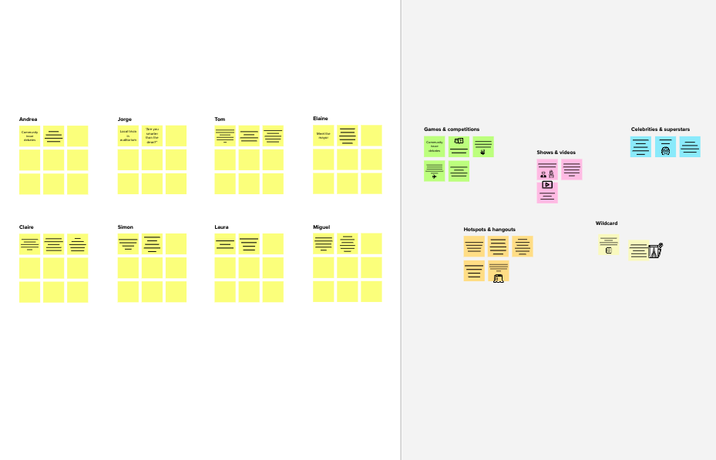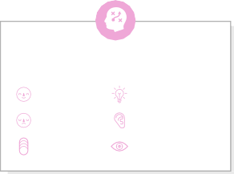

**Template**

**Need some inspiration?**

See a finished version of this template to kickstart your work.

[**Open example**](https://app.mural.co/template/e5a93b7b-49f2-48c9-afd7-a635d860eba6/93f1b98d-b2d2-4695-8e85-7e9c0d2fd9b9)